**NORMALIZATION**

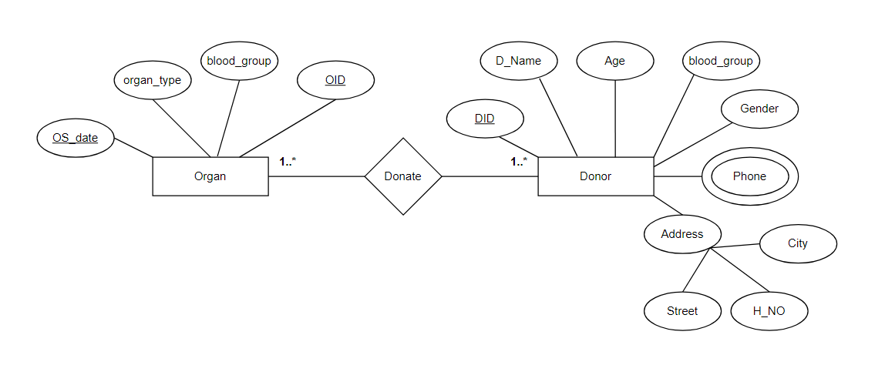

**Donate:**

**UNF:**

DID, D_NAME, AGE, BLOOD_GROUP, GENDER, PHONE, H_NO, STREET, CITY, OID, BLOOD_GROUP, ORGAN_TYPE, OS_DATE

**1NF:** PHONE is a multivalued attribute.

DID, D_NAME, AGE, BLOOD_GROUP, GENDER, H_NO, STREET, CITY, OID, BLOOD_GROUP, ORGAN_TYPE, OS_DATE

**2NF:**

1. DID, D_NAME, AGE, BLOOD_GROUP, GENDER, H_NO, STREET, CITY, OID, PID
2. PHONE, PID
3. OID, BLOOD_GROUP, ORGAN_TYPE, OS_DATE

**3NF:**

1. DID, D_NAME, AGE, BLOOD_GROUP, GENDER, OID, PID, AID
2. PID, PHONE
3. AID, H_NO, STREET, CITY
4. OID, BLOOD_GROUP, ORGAN_TYPE, OS_DATE

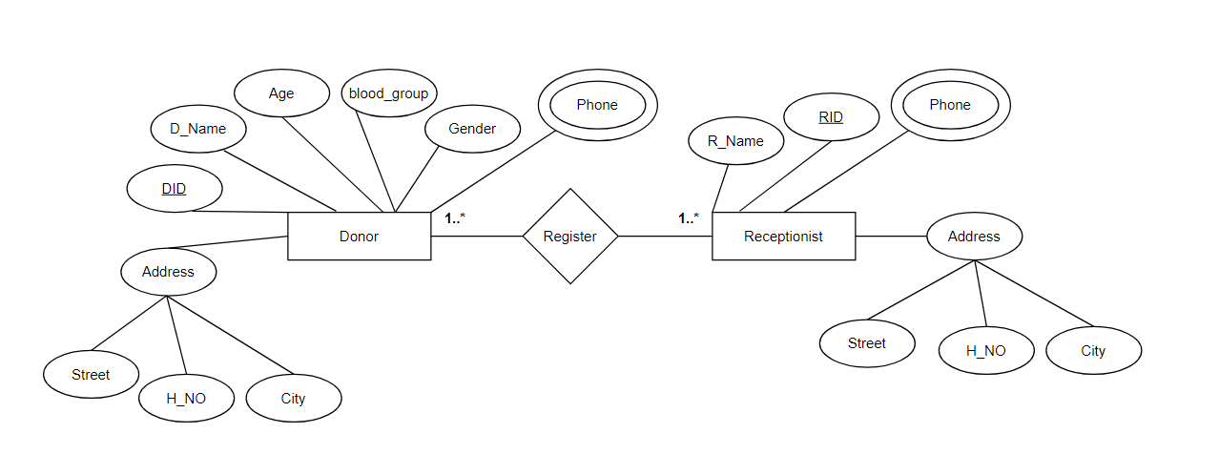

**Register:**

**UNF:**

DID, D_NAME, AGE, BLOOD_GROUP, GENDER, PHONE, H_NO, STREET, CITY, RID, R_NAME, PHONE, H_NO, STREET, CITY

**1NF:** PHONE is a multivalued attribute.

DID, D_NAME, AGE, BLOOD_GROUP, GENDER, H_NO, STREET, CITY, RID, R_NAME, PHONE, H_NO, STREET, CITY

**2NF:**

1. DID, D_NAME, AGE, BLOOD_GROUP, GENDER, H_NO, STREET, CITY, RID, PID
2. PID, PHONE
3. RID, R_NAME, H_NO, STREET, CITY, PID

**3NF:**

1. DID, D_NAME, AGE, BLOOD_GROUP, RID, PID, AID
2. PID, PHONE
3. AID, H_NO, STREET, CITY
4. RID, R_NAME, PID, AID

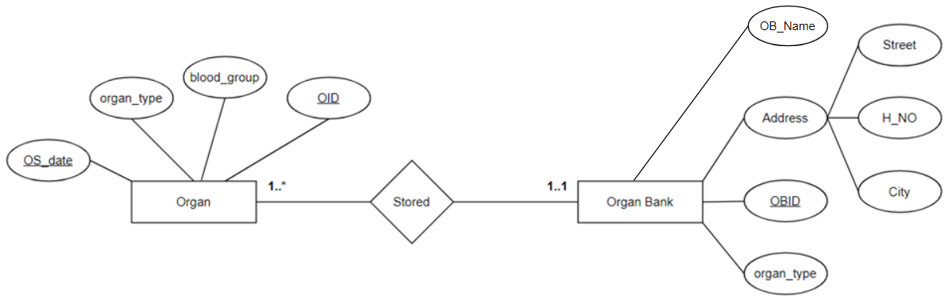

**Stored:**

**UNF:**

OID, BLOOD_GROUP, ORGAN_TYPE, OS_DATE, OBID, OB_NAME, ORGAN_TYPE, H_NO, STREET, CITY

**1NF:** **NO** is a multivalued attribute. (SAME AS **UNF**)

OID, BLOOD_GROUP, ORGAN_TYPE, OS_DATE, OBID, OB_NAME, ORGAN_TYPE, H_NO, STREET, CITY

**2NF:**

1. OID, BLOOD_GROUP, ORGAN_TYPE, OS_DATE, OBID
2. OBID, OB_NAME, ORGAN_TYPE, H_NO, STREET, CITY

**3NF:**

1. OID, BLOOD_GROUP, ORGAN_TYPE, OS_DATE, OBID
2. OBID, OB_NAME, ORGAN_TYPE, AID
3. AID, H_NO, STREET, CITY

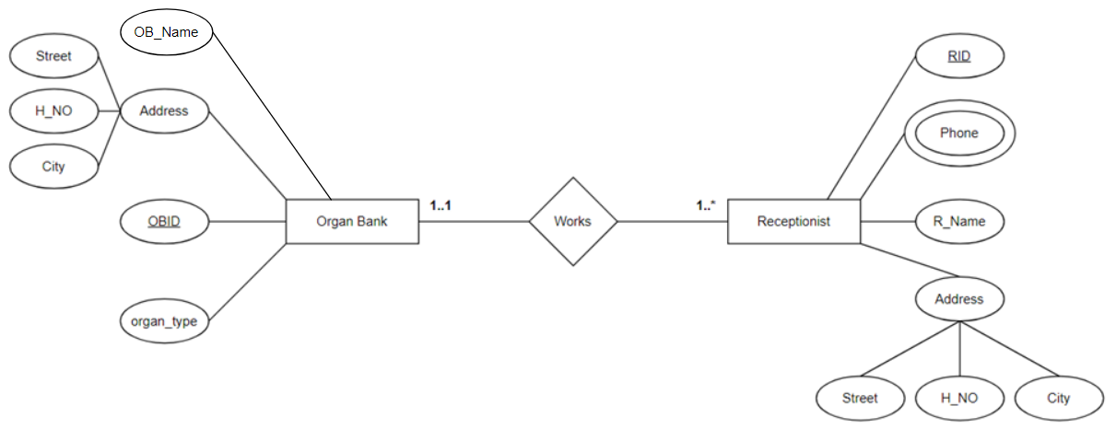

**Works:**

**UNF:**

OBID, OB_NAME, ORGAN_TYPE, H_NO, STREET, CITY, RID, R_NAME, PHONE, H_NO, STREET, CITY

**1NF:** PHONE is a multivalued attribute.

OBID, OB_NAME, ORGAN_TYPE, H_NO, STREET, CITY, RID, R_NAME, H_NO, STREET, CITY

**2NF:**

1. OBID, OB_NAME, ORGAN_TYPE, H_NO, STREET, CITY
2. PID, PHONE
3. RID, R_NAME, PHONE, H_NO, STREET, CITY, OBID, PID

**3NF:**

1. OBID, OB_NAME, ORGAN_TYPE, AID
2. PID, PHONE
3. AID, H_NO, STREET, CITY
4. RID, R_NAME, OBID, PID, AID

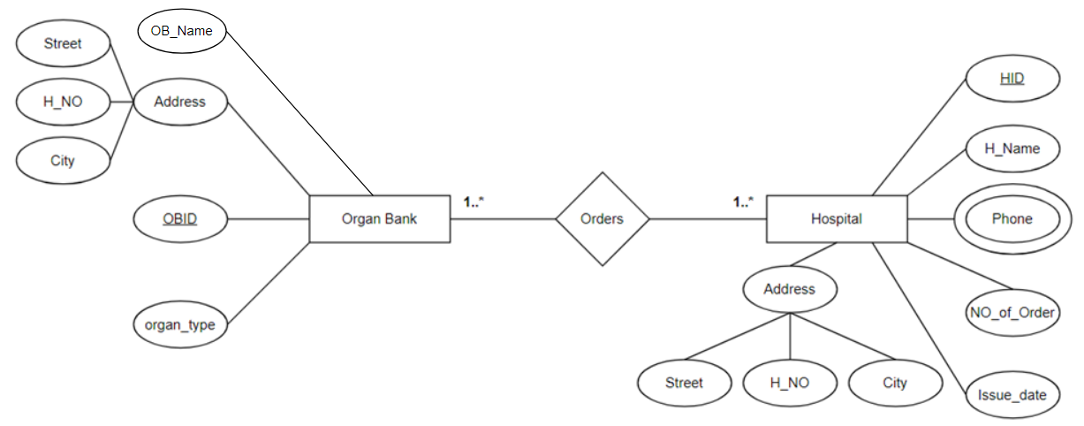

**Orders:**

**UNF:**

OBID, OB_NAME, ORGAN_TYPE, H_NO, STREET, CITY, HID, H_NAME, PHONE, NO_OF_ORDER, ISSUE_DATE, H_NO, STREET, CITY

**1NF:** PHONE is a multivalued attribute.

OBID, OB_NAME, ORGAN_TYPE, H_NO, STREET, CITY, HID, H_NAME, NO_OF_ORDER, ISSUE_DATE, H_NO, STREET, CITY

**2NF:**

1. OBID, OB_NAME, ORGAN_TYPE, H_NO, STREET, CITY
2. PID, PHONE
3. HID, H_NAME, NO_OF_ORDER, ISSUE_DATE, H_NO, STREET, CITY, OBID, PID

**3NF:**

1. OBID, OB_NAME, ORGAN_TYPE, AID
2. PID, PHONE
3. AID, H_NO, STREET, CITY
4. HID, H_NAME, NO_OF_ORDER, ISSUE_DATE, OBID, PID, AID

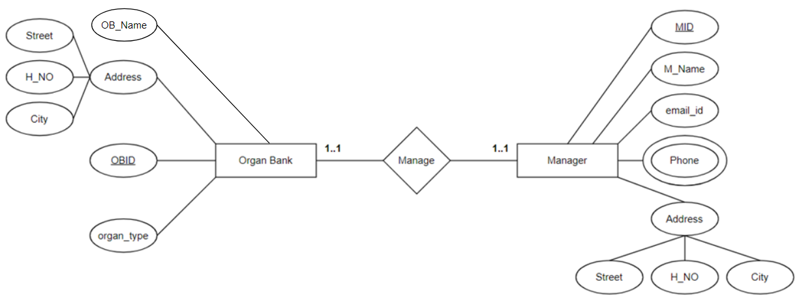

**Manage:**

**UNF:**

OBID, OB_NAME, ORGAN_TYPE, H_NO, STREET, CITY, MID, M_NAME, EMAIL_ID, PHONE, H_NO, STREET, CITY

**1NF:** PHONE is a multivalued attribute.

OBID, OB_NAME, ORGAN_TYPE, H_NO, STREET, CITY, MID, M_NAME, EMAIL_ID, H_NO, STREET, CITY

**2NF:**

1. OBID, OB_NAME, ORGAN_TYPE, H_NO, STREET, CITY
2. PID, PHONE
3. MID, M_NAME, EMAIL_ID, H_NO, STREET, CITY, OBID, PID

**3NF:**

1. OBID, OB_NAME, ORGAN_TYPE, AID
2. PID, PHONE
3. AID, H_NO, STREET, CITY
4. MID, M_NAME, EMAIL_ID, OBID, PID, AID